## **What is Coin98 Exchange**?

Coin98 Exchange is a decentralized exchange (DEX), a Multi-chain liquidity aggregator that offers users a wide variety of DeFi services (swap, stake, lend, borrow,...) through intuitive and simple interfaces.

Coin98 Exchange was born to solve the problem of liquidity fragmentation on many Blockchains, helping users to experience DeFi fully and seamlessly without the need for in-depth knowledge of blockchain technology.

Known as a decentralized, non-custodial version of the leading CEXs in the market, Coin98 Exchange is gradually bringing essential services in the traditional economy to DeFi such as:

* Trading with **Exchange**;
* Market data aggregator tool with **Markets**;
* Asset management tool with **Portfolio**;
* Utility toolkit for DeFi users with **Terminals**;
* And some upcoming features like **Staking, Cross-chain Swap,…**

## Features of Coin98 Exchange

Coin98 Exchange has 4 main features, include:

**Coin98 Exchange:** Provides crucial sources of liquidity for swapping tokens in a trustless, permissionless, and seamless manner.

**Coin98 Markets:**Delivers vital cryptocurrency market data visually engagingly, empowering users with actionable insights.

**Coin98 Portfolio:**Supports users to monitor price changes and the growth of their assets on **11+ blockchain.**

**Coin98 Terminal includes:**

* **Token Issuer:** Create your own token in just 1 minute with no coding experience
* **Multi-sender:** Send multiple outputs to different addresses in only one transaction.
* **Wallet Approval:**revoking token allowances from dApps on all supported Blockchains, and protecting users from potential loss risks.
* **Solana Migration:**a solution that helps users to migrate their associated SPL tokens to a single SOL wallet address and prevent the fragmentation of users’ assets when interacting with Solana DApps.

## Overview of the Coin98 Exchange interface

Coin98 offers users 2 types of interface:

**The Pro-UI**with in-depth trading information and features for active traders and more advanced users

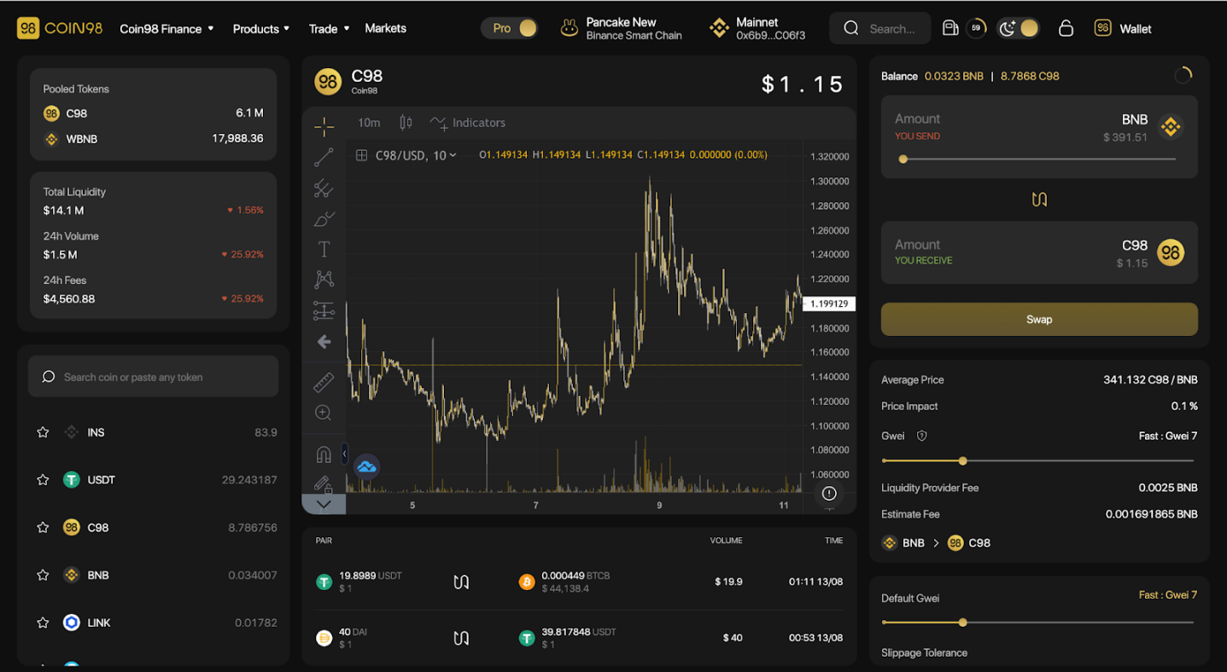

**The Basic - UI** with a streamlined interface that focuses on simplicity, speed, and ease-of-use, making Coin98 Exchange a perfect choice for crypto novices, first-time users, and users who just need the basics.

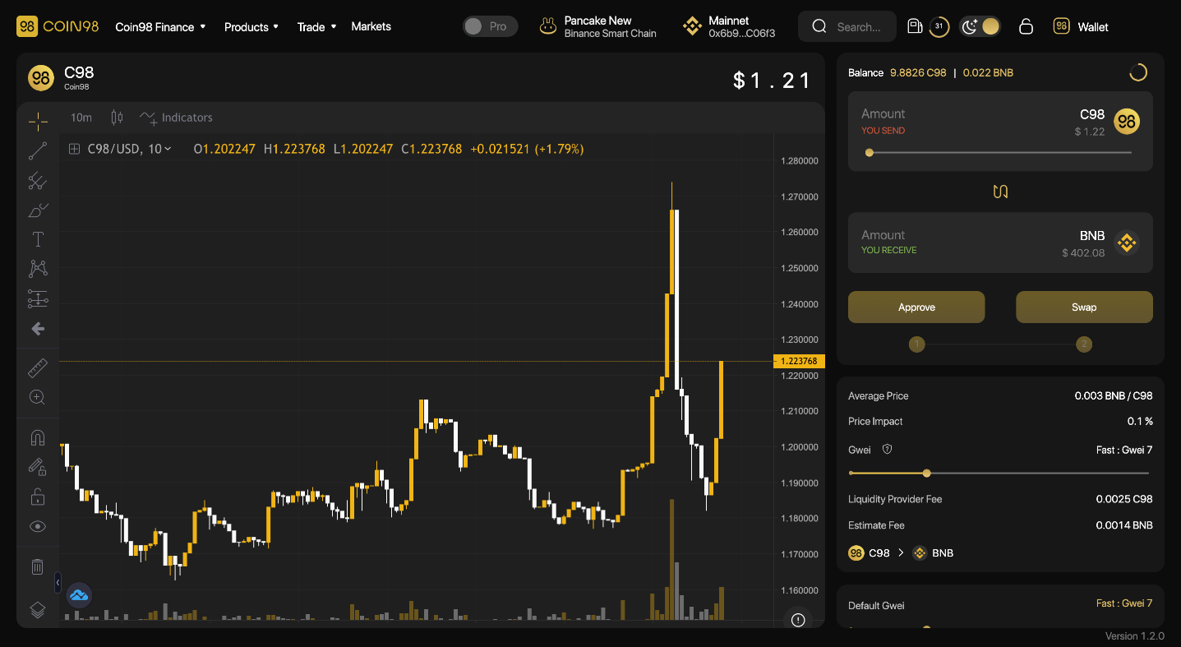

The main interface of Coin98 Exchange has the following sections:

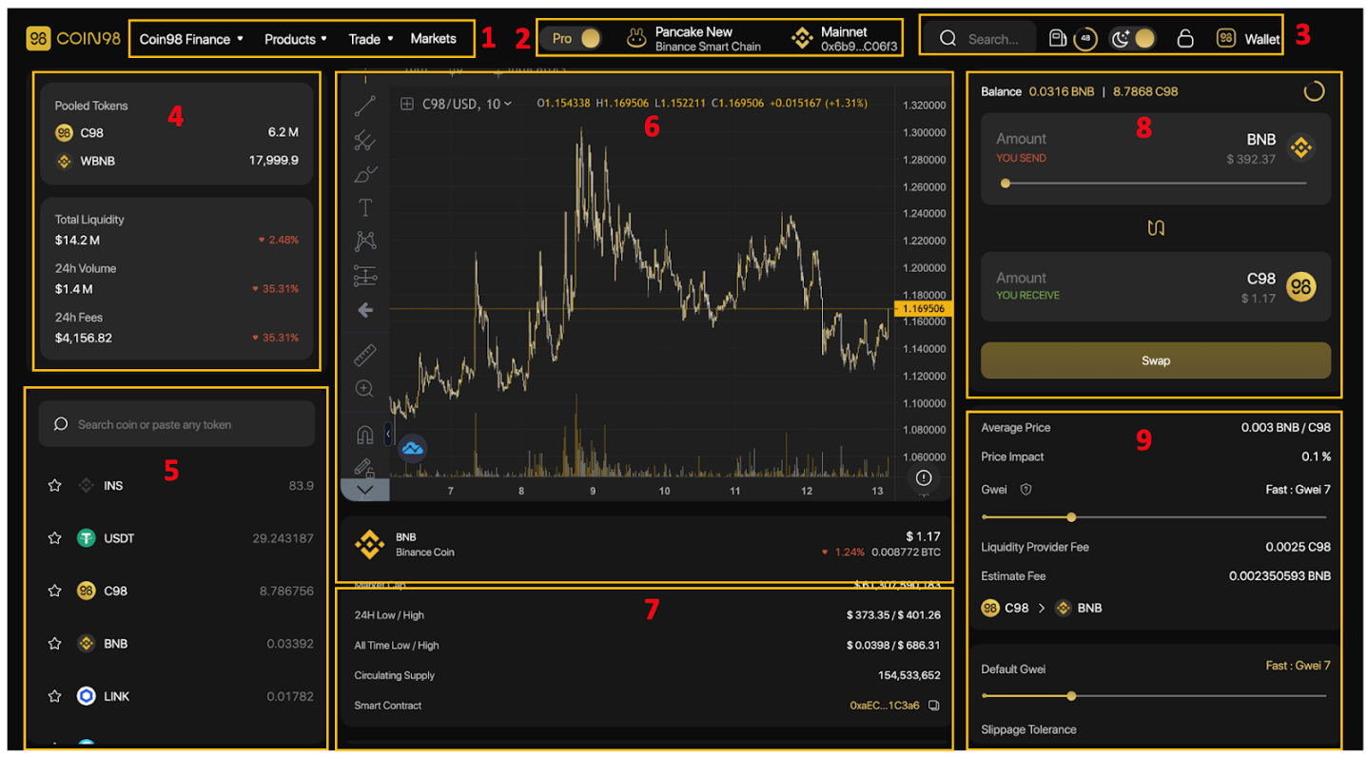

**[1] Navigation**to other Coin98's sites, products and AMMs of Coin98 Exchange.

**[2] From left to right:**

* A toggle switch to change between the Pro UI interface and the Basic UI interface.
* The DEX selection area.
* The Wallet connected to Coin98 Exchange (you can change between wallets if there is more than 1).

**[3] Some built-in utilities:**

* **The search bar:** Search the tokens with their names, symbols, or smart contract addresses.
* **The Gas station icon:**Real-time Gwei.
* **The Moon icon:**Light and dark interface settings.
* **The Lock icon:**Lock/Unlock the wallet.
* **Wallet:** Manage wallet and receive/send tokens.

**[4] Information about the 2 chosen tokens in the pool:**

* Current number of tokens in the pool.
* **Total Liquidity:** The current total liquidity in the pool in USD.
* **24h Volume:** The total trading volume of the pool within 24 hours, % of change within 24 hours.
* **24h Fees:**The total swap fee of the pool in 24h, % of change within 24h.

***\*Note:****This area will not be displayed in the Basic interface.*

**[5]**The Token selection area.

**[6]** The price chart of the token that you intend to swap including:

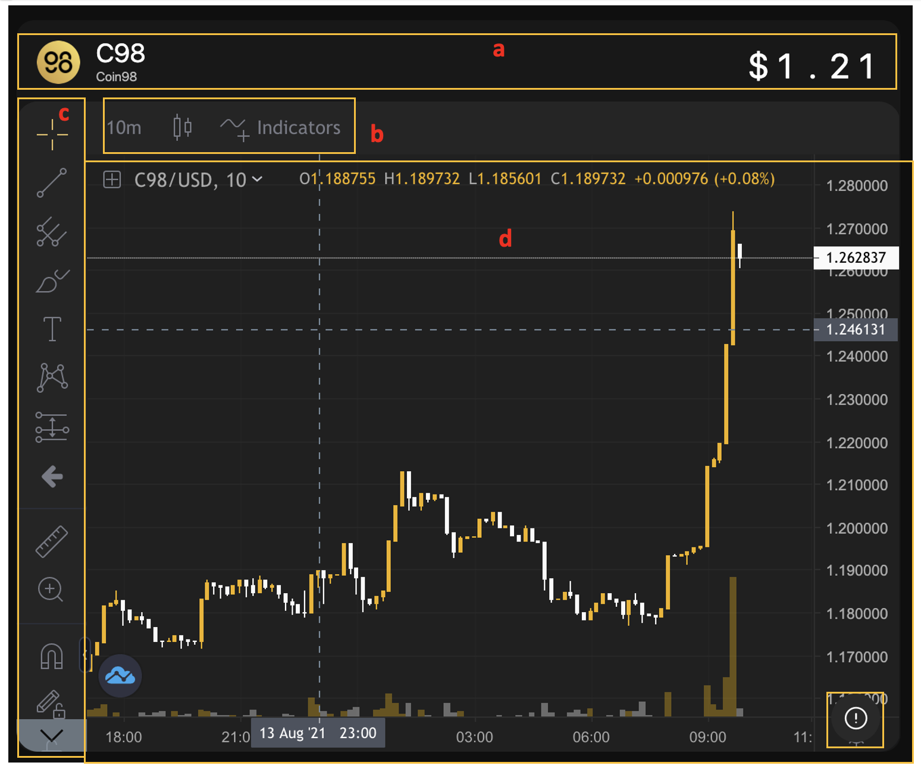

* **[a]**Name, sticker, logo, and real-time price of the swapped token.
* **[b]** Watch time adjustment (1 minute - 1 week), available indicator-related tools, types of candles.
* **[c]**The Drawing and measuring tools. However, to use these tools you need to have knowledge of technical analysis.
* **[d]** The largest area, where the price chart is placed as well as where all the tools are applied, showing the indicators for price analysis.

Users can click the **(!)** icon at the lower-left corner of the price chart to view more information about the token.

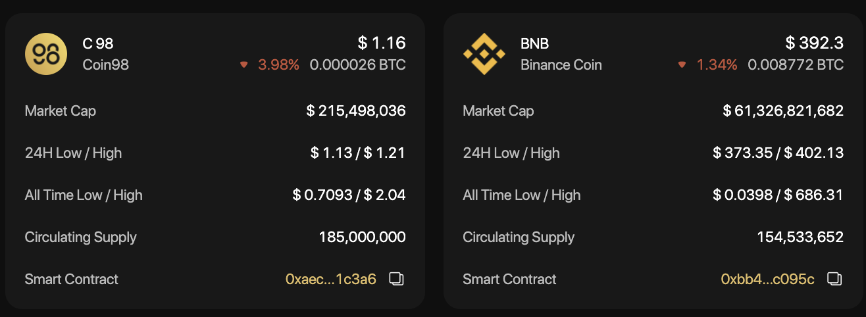

**[7]**History of transactions.

**[8]**The transaction area.

**[9]**The transaction information as well as the main settings:

* **Average Price:**The average price ratio of the 2 tokens.
* **Price impact:**The difference between the market price and the estimated price provided by the Liquidity Pool.
* **Gwei:**Can be considered as the transaction fee - a payment made by users to complete transactions on blockchains.
* **Liquidity Provider Fee:**The fee you have to pay to the liquidity provider
* **Estimate Fee:** The estimated transaction fee that you have to pay for the network.

**Advanced Settings:**

* **Gwei bar:** A feature that allows users to adjust the amount of Gas fee (transaction fee) according to their needs by sliding the bar.
* **Slippage tolerance:** The pricing difference between the price at the confirmation time and the actual price of the transaction users are willing to accept when swapping on AMMs. **Slippage tolerance** is set as a percentage of the total swap value.
* **Transaction Deadline:** The maximum transaction time that you can specify to avoid the case of long waiting time without any matching orders.
* **Unlimited Approval:**A feature that enables users to grant platforms and smart contracts the permission to spend tokens/ coins on your behalf without limit.
* **Default Pair:**The default tokens for each trading pair
* **Contract revoke:**Allows you to inspect all contracts you've approved to spend money on your behalf and revoke their access for the ones you no longer need. The example shows that I have allowed PancakeSwap (V2) to use a very large amount of USDT, if I feel it is not necessary, I will click on the crossed-out icon on the right.

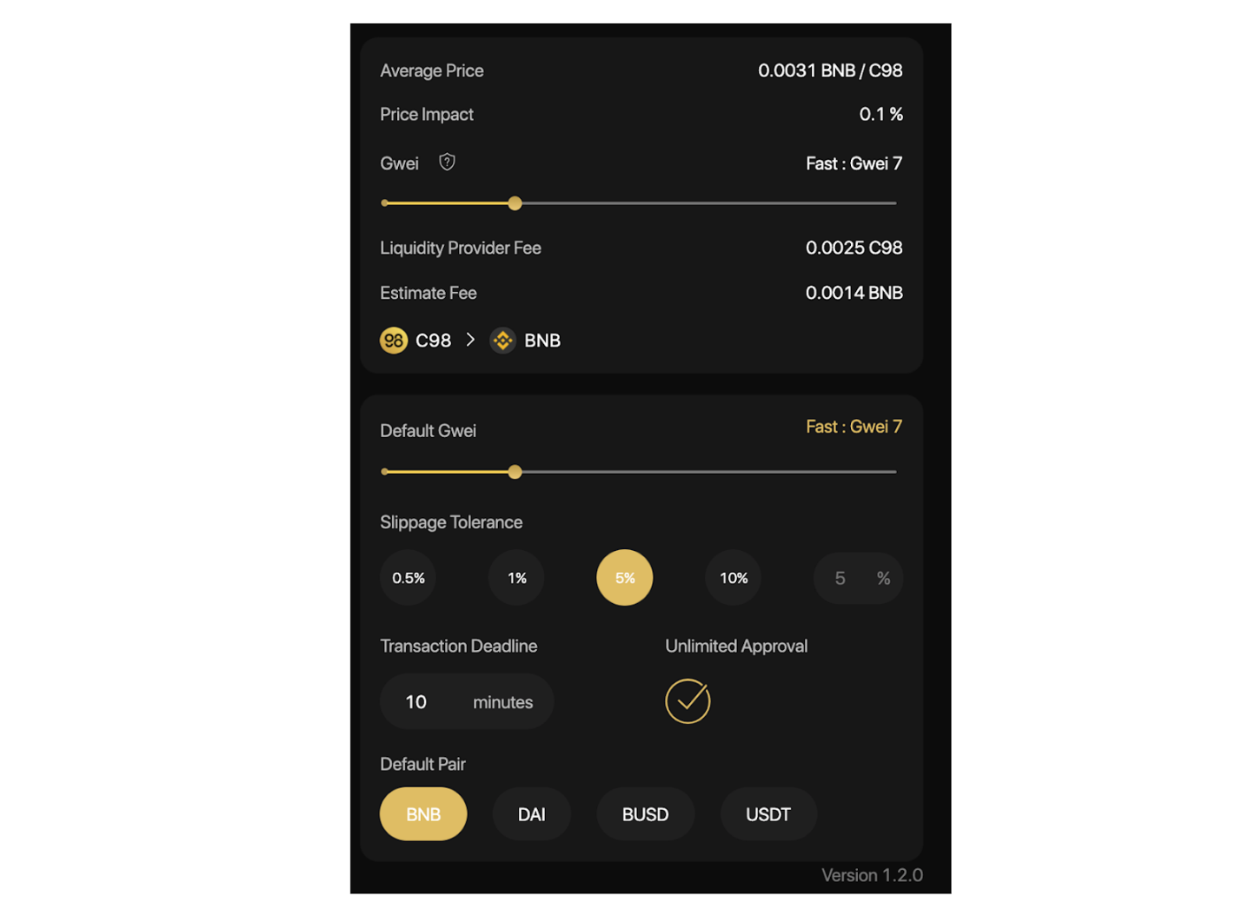

## How to trade on Coin98 Exchange

**Step 1:** Select the AMM you want to trade with by clicking on one of the two highlighted sections on the screen.

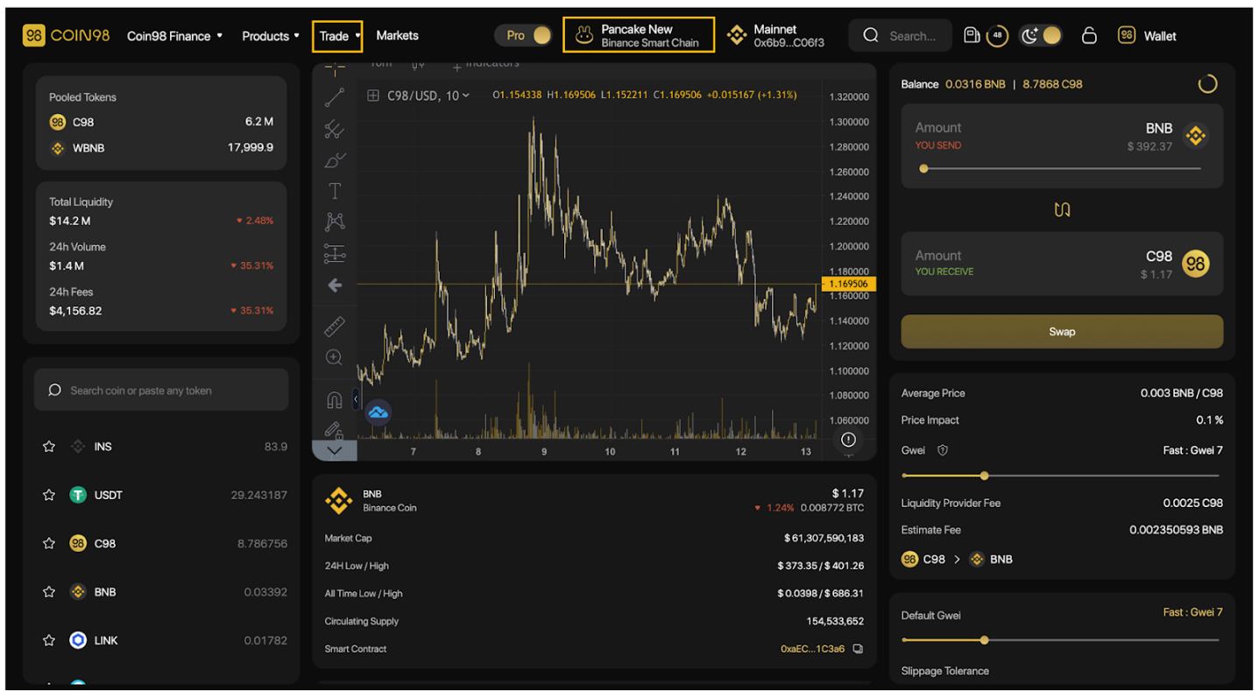

In this case, I will take PancakeSwap New as an example.

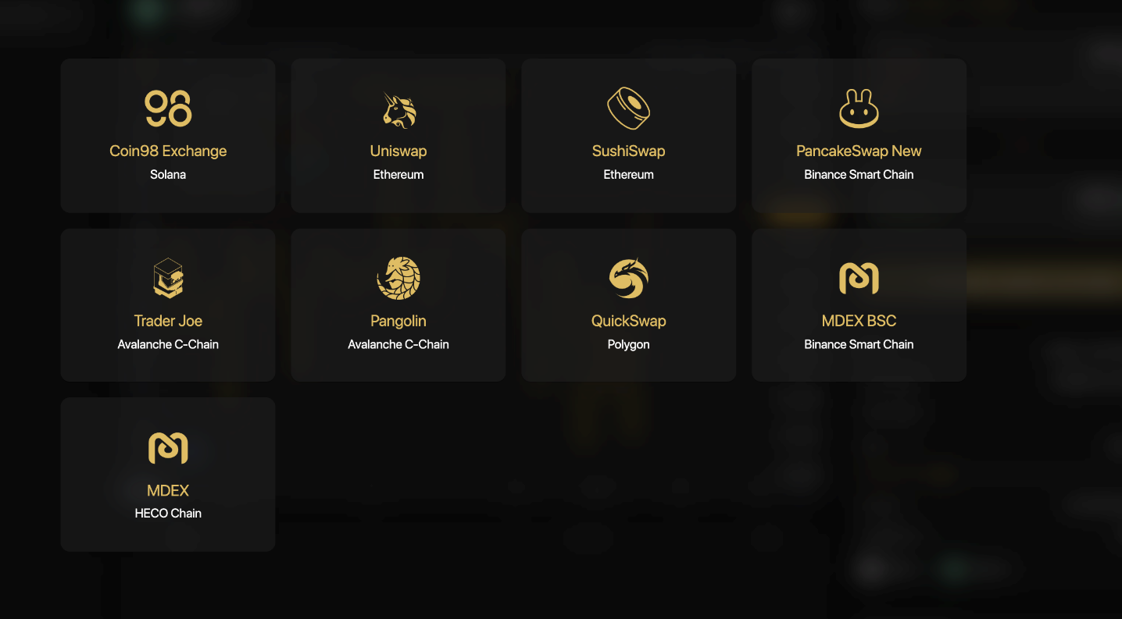

**Step 2:** Select the token you want to trade from the token search bar.

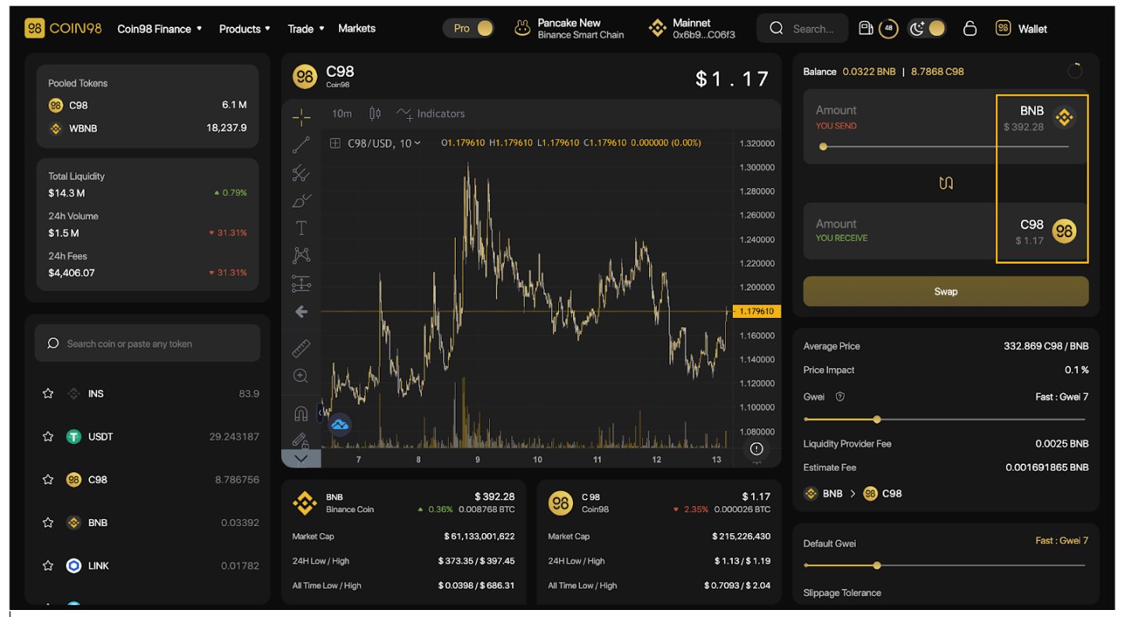

For new tokens that have not been listed on Coin98 Exchange, you can paste their Contract addresses and trade as usual.

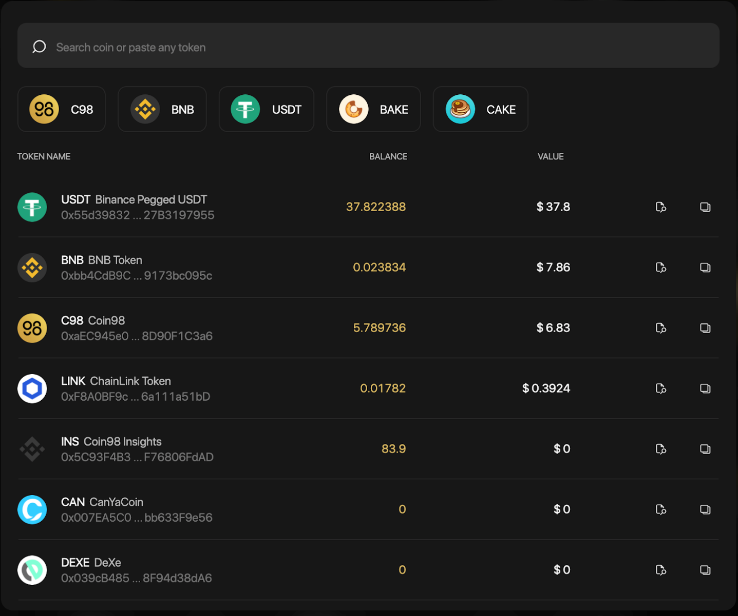

I will take the USDT-C98 trading pair as an example.

**Step 3:**At the transaction area, you can:

* Slide the bar or enter the desired amount of tokens you want to trade.
* Adjust the Gwei bar according to the desired speed. The default gas fee on Coin98 Wallet has been set for the highest speed with the most reasonable cost.
* Adjust the Slippage tolerance according to the desired slippage. The default slippage tolerance on Coin98 Wallet is set at the standard rate of +/-5%, which is quite safe and applicable to most coins on the market.
* Adjust the Transaction Deadline according to the desired waiting time. The default transaction deadline on Coin98 Wallet is set at the standard rate of 10 minutes.
* Click**Swap.**

**Step 4:** Click **Confirm** to confirm that you agree with the fee and are ready to make this transaction.

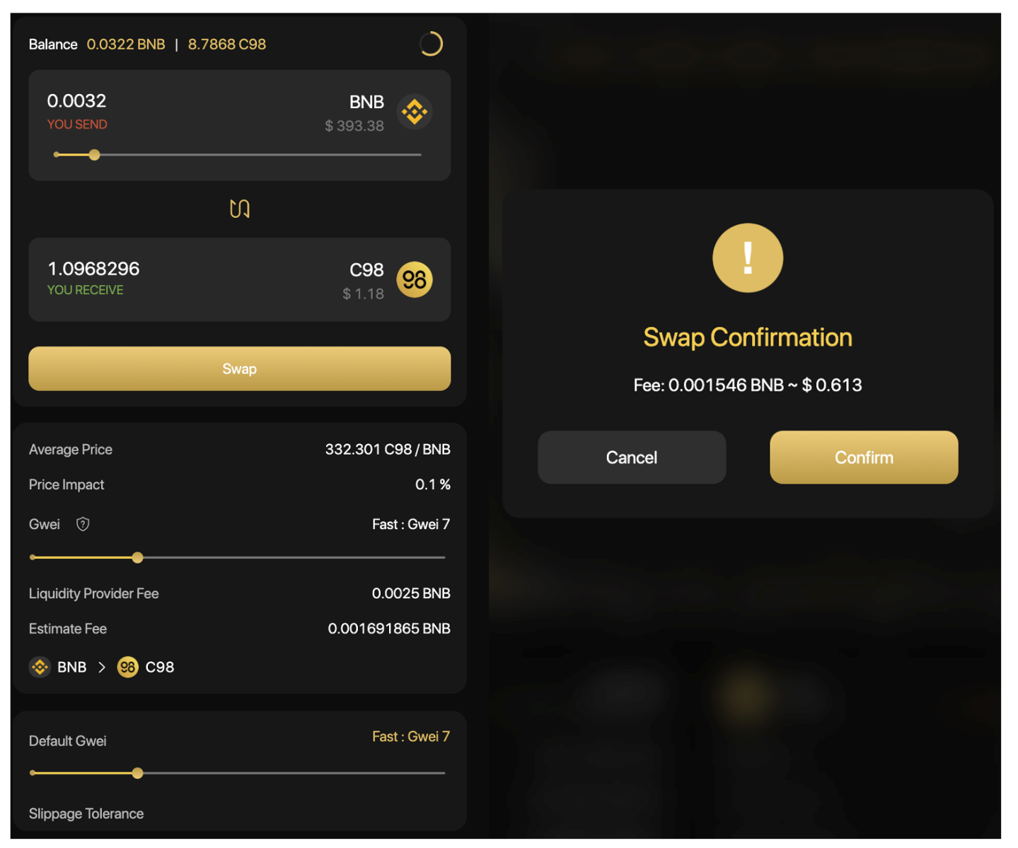

When the transaction is completed, you will receive a notification at the bottom right corner of the screen.

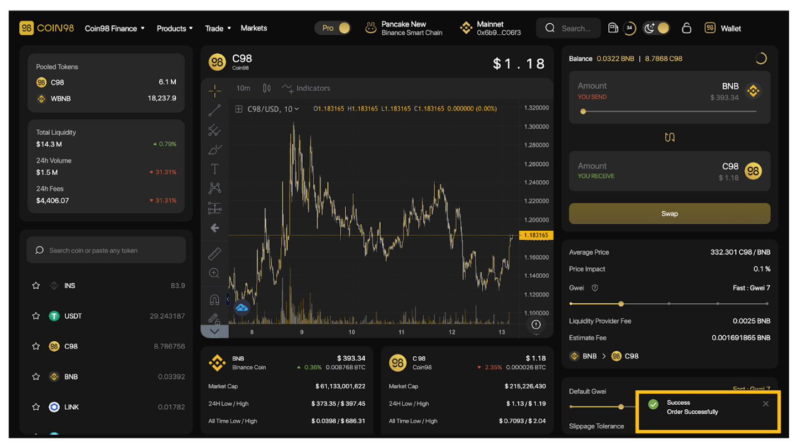

**Note:**

* The arrow in the middle of the trading interface is used to switch between the buying and selling positions. You need to check the tokens’ positions carefully before making any transactions.
* The gas fee and the processing time are different on each blockchain. You need to double-check the information carefully before approving any transaction.
* After swapping successfully, you can access the Pair section to view your transactions.

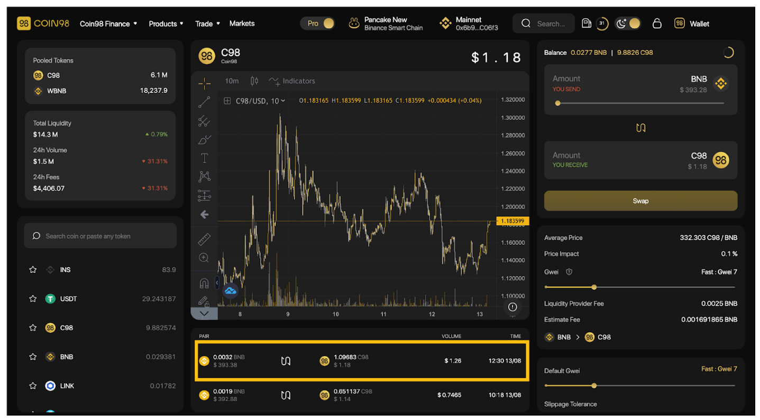

In the future, Coin98 Exchange will integrate more top-tier AMMs and cross-chain bridges to elevate users' trading experience to a new level.